
DURHAM POLICE DEPARTMENT
USE OF FORCE INJURY TO CITIZEN
OFFICER ASSAULTED DOMESTIC ANIMAL EUTHANASIA
RESPONSE TO ANIMAL AGGRESSION TOWARDS PERSON/PUBLIC

Date: __________ Time: _________ Location: ____________________________________________________
Indoors Outdoors Lighting Conditions: ____________________________________________
Photographs Taken YES NO
OFFICER
Officer Involved: _______________________________________ Employee #: __________________________
Officer Assaulted? YES NO Officer Injured? YES NO
Describe Nature and Extent of Officer Injuries: ____________________________________________________
___________________________________________________________________________________________
RESPONSE
Firearm K-9 EID Aerosol Weapon Impact Weapon Hard Hands
Other __________________________________________________________________________________
Justification: _________________________________________________________________________________
____________________________________________________________________________________________
____________________________________________________________________________________________
EID
Number of Cartridges Fired: __________________ Number of Cycles Applied: ____________________
Dart Probe Contact Penetrate Skin Penetrate Clothing Only
Approximate Distance from Subject: _______________ Distance (Inches) Between Probes: _________________
Probes Removed by: _________________________________________ Employee #: ______________________
Location: In Field Jail Hospital Other: _______________________________________
Serial Number(s) of Cartridge(s): ________________________________________________________________
Drive Stun Contact Number of Cycles: ______________________

CITIZEN
Name of Citizen: ______________________________________________________________________________
Race: __________ Sex: __________ DOB: ___________________ Height: ___________ Weight: ____________
Address: _____________________________________________________________________________________
Citizen Injured? No Yes – Nature and Extent of Citizen’s Injuries________________________________
____________________________________________________________________________________________
____________________________________________________________________________________________
Citizen Arrested? No Yes - Charges: _____________________________________________________
____________________________________________________________________________________________

DOMESTIC ANIMAL
Type of Animal: ______________________________________________________________________________
Owner Notified: Yes No Notified by: ______________________________________________
Owner’s Name: ______________________________________________________________________________
Owner’s Address: ____________________________________________________________________________
Animal Injuries (Post-Incident): _________________________________________________________________

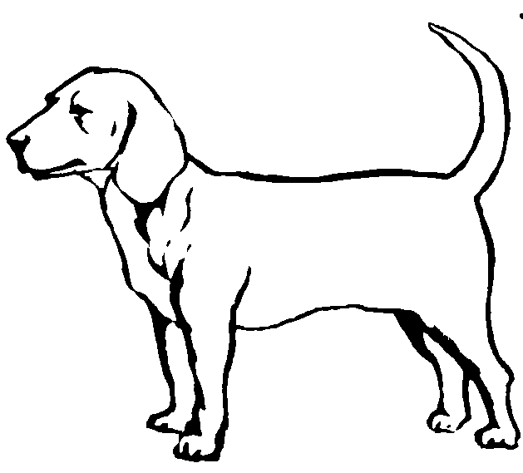
AFFECTED BODY LOCATION
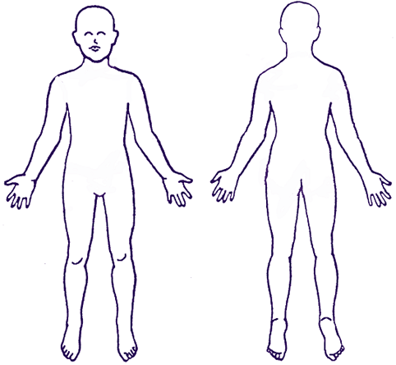
Indicate Body Locations Affected

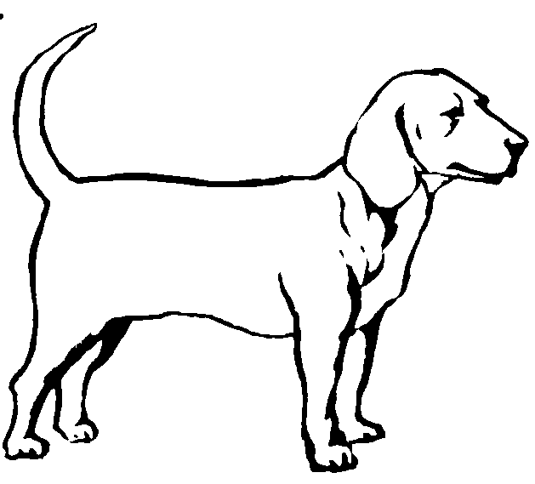
Left

Front Back Right
Supervisor: _____________________________________________________ Employee #: ___________________
Comments: ___________________________________________________________________________________
_____________________________________________________________________________________________
Supervisor Signature: ___________________________________________________ Date: ___________________
SUBMIT TO PROFESSIONAL STANDARDS PROMPTLY - DO NOT DUPLICATE THIS FORM

